Stakeholder Matrix

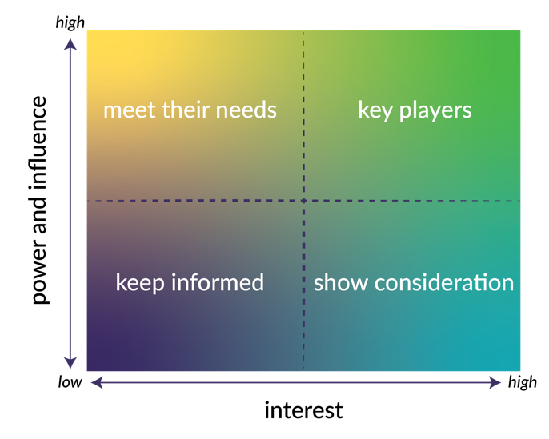

Key players
These are the stakeholders who are part of your key team. These form the core of your stakeholder network and should be part of your decision-making core.

Show consideration
Those in the show consideration quadrant may be quite invested in the issue, but do not necessarily carry much influence. These stakeholders may still be important. You may want to find out what is important to them as they can be important in mobilizing knowledge and can play a role in spreading the word abut your efforts for change.

Meet their needs
It is important to understand and be responsive to the needs of this group. Find ways to understand what these needs are and ensure these are addressed in your project. Examples of stakeholders in this category could be funders or a board of directors. They should NOT be directly involved in the day-to-day running of your project, but you should ensure that needs understood and met.

Keep Informed
This group tends to get overlooked as they seemingly wield little influence and are relatively disinterested in the issue; however, in a distributed environment (i.e., a coalition), their perspectives can impact the perception of your work. It is therefore important to acknowledge the stakeholders in this group and keep them informed.

